**Yousef Jarrar, Jose Perez**

**CSE 461**

**Lab 1**

**20 Total Points.**

1. **Writing a Simple Shell**

/*Yousef Jarrar - Jose Perez

Dr. Tong Yu

Part 1 - Writing a Simple Shell

Lab 1

*/

#include < stdio.h >

#include < stdlib.h >

#include < sys / wait.h >

#include < unistd.h >

#include < string.h >

void read_command(char cmd[], char * par[]) {

char line[1024];

int count = 0, i = 0, j = 0;

char * array[100], * pch;

for (;;) {

int c = fgetc(stdin);

line[count++] = (char) c;

if (c == '\n') break;

}

if (count == 1) return;

pch = strtok(line, " \n");

//Parse the line into words

while (pch != NULL) {

array[i++] = strdup(pch);

pch = strtok(NULL, " \n");

}

//first word is the command

strcpy(cmd, array[0]);

for (int j = 0; j < i; j++)

par[j] = array[j];

par[i] = NULL;

}

void type_prompt() {

static int first_time = 1;

if (first_time) {

const char * CLEAR_SCREEN_ANSI = " \e[1;1H\e[2J";

write(STDOUT_FILENO, CLEAR_SCREEN_ANSI, 12);

first_time = 0;

}

printf("#");

}

int main() {

char cmd[100], command[100], * parameters[20];

char * envp[] = {

(char * )

"PATH=/bin",

0

};

while (1) {

type_prompt();

read_command(command, parameters);

if (fork() != 0) {

wait(NULL);

} else {

strcpy(cmd, "/bin/");

strcat(cmd, command);

execve(cmd, parameters, envp);

}

if (strcmp(command, "exit") == 0) {

break;

}

}

return 0;

}

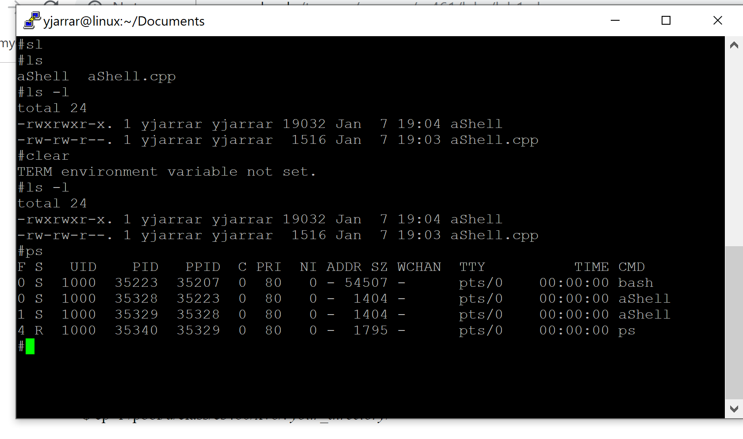

**3. Debugging**

**Part A:**

*[yjarrar@linux xv6-public]$ gdb*

*GNU gdb (GDB) Fedora 8.2-5.fc29*

*Copyright (C) 2018 Free Software Foundation, Inc.*

*License GPLv3+: GNU GPL version 3 or later <http://gnu.org/licenses/gpl.html>*

*This is free software: you are free to change and redistribute it.*

*There is NO WARRANTY, to the extent permitted by law.*

*Type "show copying" and "show warranty" for details.*

*This GDB was configured as "x86_64-redhat-linux-gnu".*

*Type "show configuration" for configuration details.*

*For bug reporting instructions, please see:*

*<http://www.gnu.org/software/gdb/bugs/>.*

*Find the GDB manual and other documentation resources online at:*

*<http://www.gnu.org/software/gdb/documentation/>.*

*For help, type "help".*

*Type "apropos word" to search for commands related to "word".*

*warning: File "/home/yjarrar/Documents/Lab 1/xv6-public/.gdbinit" auto-loading .*

*To enable execution of this file add*

*add-auto-load-safe-path /home/yjarrar/Documents/Lab 1/xv6-public/.gdbint*

*line to your configuration file "/home/yjarrar/.gdbinit".*

*To completely disable this security protection add*

*set auto-load safe-path /*

*line to your configuration file "/home/yjarrar/.gdbinit".*

*For more information about this security protection see the*

*--Type <RET> for more, q to quit, c to continue without paging--c*

*"Auto-loading safe path" section in the GDB manual. E.g., run from the shell:*

*info "(gdb)Auto-loading safe path"*

*(gdb) target remote:26000*

*Remote debugging using :26000*

*warning: Remote gdbserver does not support determining executable automatically.*

*RHEL <=6.8 and <=7.2 versions of gdbserver do not support such automatic executable detection.*

*The following versions of gdbserver support it:*

*- Upstream version of gdbserver (unsupported) 7.10 or later*

*- Red Hat Developer Toolset (DTS) version of gdbserver from DTS 4.0 or later (only on x86_64)*

*- RHEL-7.3 versions of gdbserver (on any architecture)*

*warning: No executable has been specified and target does not support*

*determining executable automatically. Try using the "file" command.*

*0x0000fff0 in ?? ()*

*(gdb) file kernel*

*A program is being debugged already.*

*Are you sure you want to change the file? (y or n) y*

*Reading symbols from kernel...done.*

*(gdb) break swtch*

*Breakpoint 1 at 0x8010479b: file swtch.S, line 11.*

*(gdb) continue*

*Continuing.*

*Thread 1 hit Breakpoint 1, swtch () at swtch.S:11*

*11 movl 4(%esp), %eax*

*(gdb) step*

*12 movl 8(%esp), %edx*

*(gdb) step*

*15 pushl %ebp*

*(gdb) step*

*swtch () at swtch.S:16*

*16 pushl %ebx*

*(gdb) step*

*swtch () at swtch.S:17*

*17 pushl %esi*

*(gdb) step*

*swtch () at swtch.S:18*

*18 pushl %edi*

*(gdb) steo*

*Undefined command: "steo". Try "help".*

*(gdb) step*

*swtch () at swtch.S:21*

*21 movl %esp, (%eax)*

*(gdb) step*

*22 movl %edx, %esp*

*(gdb) step*

*swtch () at swtch.S:25*

*25 popl %edi*

*(gdb) step*

*swtch () at swtch.S:26*

*26 popl %esi*

*(gdb) step*

*swtch () at swtch.S:27*

*27 popl %ebx*

*(gdb) step*

*swtch () at swtch.S:28*

*28 popl %ebp*

*(gdb) step*

*swtch () at swtch.S:29*

*29 ret*

*(gdb) step*

*forkret () at proc.c:401*

*401 release(&ptable.lock);*

*(gdb) step*

*release (lk=0x80112d20 <ptable>) at spinlock.c:49*

*49 if(!holding(lk))*

*(gdb) step*

*holding (lock=0x80112d20 <ptable>) at spinlock.c:94*

*94 r = lock->locked && lock->cpu == mycpu();*

*(gdb) step*

*mycpu () at x86.h:99*

*99 return eflags;*

*(gdb) step*

*45 apicid = lapicid();*

*(gdb) step*

*lapicid () at lapic.c:103*

*103 if (!lapic)*

*(gdb) step*

*105 return lapic[ID] >> 24;*

*(gdb) step*

*mycpu () at proc.c:48*

*48 for (i = 0; i < ncpu; ++i) {*

*(gdb) step*

*49 if (cpus[i].apicid == apicid)*

*(gdb) step*

*50 return &cpus[i];*

*(gdb) step*

*popcli () at x86.h:99*

*99 return eflags;*

*(gdb) step*

*121 if(--mycpu()->ncli < 0)*

*(gdb) stpe*

*Undefined command: "stpe". Try "help".*

*(gdb) step*

*mycpu () at x86.h:99*

*99 return eflags;*

*(gdb) step*

*45 apicid = lapicid();*

*(gdb) continue*

*Continuing.*

*Thread 1 hit Breakpoint 1, swtch () at swtch.S:11*

*11 movl 4(%esp), %eax*

*(gdb) clear*

*Deleted breakpoint 1*

*(gdb) break exec*

*Breakpoint 2 at 0x80100a80: file exec.c, line 20.*

*(gdb) continue*

*Continuing.*

*[Switching to Thread 2]*

*Thread 2 hit Breakpoint 2, exec (path=0x1c "/init", argv=0x8dfffed0) at exec.c:20*

*20 struct proc *curproc = myproc();*

*(gdb) continue*

*Continuing.*

*Thread 2 hit Breakpoint 2, exec (path=0x846 "sh", argv=0x8dffeed0) at exec.c:20*

*20 struct proc *curproc = myproc();*

*(gdb) continue*

*Continuing.*

*[Switching to Thread 1]*

*Thread 1 hit Breakpoint 2, exec (path=0x18e0 "ls", argv=0x8dfbeed0) at exec.c:20*

*20 struct proc *curproc = myproc();*

*(gdb)*

**Explanation: We started off with running “xv6” in a terminal. We then opened a second session of the terminal command line and started a gbd connection on port 26000. We then loaded the Kernel File and inserted a Breakpoint (context switching) to start the debugging process. We were able to determine the different points of how the xv6 boots, and observed the different opcodes that were being used during the process. Once completed, we cleared the breakpoint and inserted another (exec system call). We noticed that at this point the kernel loaded it’s first user-mode process “init”. It then loads into an interactive shell program and stops as it is waiting for a command (we noticed this on the operating system side, opposite of gdb). Once it was supplied with a system call “ls -l” the operating system continued to work, until the next hang (user input).**

**Part B:**

*(gdb) disass*

*Dump of assembler code for function mycpu:*

*0x80103840 <+0>: push ebp*

*0x80103841 <+1>: mov ebp,esp*

*0x80103843 <+3>: push esi*

*0x80103844 <+4>: push ebx*

*0x80103845 <+5>: pushf*

*0x80103846 <+6>: pop eax*

*0x80103847 <+7>: test ah,0x2*

*0x8010384a <+10>: jne 0x801038a9 <mycpu+105>*

*0x8010384c <+12>: call 0x80102830 <lapicid>*

*=> 0x80103851 <+17>: mov esi,DWORD PTR ds:0x80112d00*

*0x80103857 <+23>: test esi,esi*

*0x80103859 <+25>: jle 0x8010389c <mycpu+92>*

*0x8010385b <+27>: movzx edx,BYTE PTR ds:0x80112780*

*0x80103862 <+34>: cmp eax,edx*

*0x80103864 <+36>: je 0x80103895 <mycpu+85>*

*0x80103866 <+38>: xor edx,edx*

*0x80103868 <+40>: lea esi,[esi+eiz*1+0x0]*

*0x8010386f <+47>: nop*

*0x80103870 <+48>: add edx,0x1*

*0x80103873 <+51>: cmp edx,esi*

*0x80103875 <+53>: je 0x8010389c <mycpu+92>*

*0x80103877 <+55>: imul ecx,edx,0xb0*

*--Type <RET> for more, q to quit, c to continue without paging--c*

*0x8010387d <+61>: movzx ebx,BYTE PTR [ecx-0x7feed880]*

*0x80103884 <+68>: cmp ebx,eax*

*0x80103886 <+70>: jne 0x80103870 <mycpu+48>*

*0x80103888 <+72>: lea eax,[ecx-0x7feed880]*

*0x8010388e <+78>: lea esp,[ebp-0x8]*

*0x80103891 <+81>: pop ebx*

*0x80103892 <+82>: pop esi*

*0x80103893 <+83>: pop ebp*

*0x80103894 <+84>: ret*

*0x80103895 <+85>: mov eax,0x80112780*

*0x8010389a <+90>: jmp 0x8010388e <mycpu+78>*

*0x8010389c <+92>: sub esp,0xc*

*0x8010389f <+95>: push 0x801074dc*

*0x801038a4 <+100>: call 0x80100390 <panic>*

*0x801038a9 <+105>: sub esp,0xc*

*0x801038ac <+108>: push 0x801075b8*

*0x801038b1 <+113>: call 0x80100390 <panic>*

*End of assembler dump.*

**Part C:**

/*********************************************************************************************

* cp.c

* By: Yousef Jarrar and Jose Perez

* CSE 461 Lab 1

*********************************************************************************************/

#include "types.h"

#include "stat.h"

#include "user.h"

#include "fcntl.h"

char buf[512];

int main(int argc, char *argv[]) {

int fd0, fd1, fd2, n;

if (argv <= 2) {

printf(1, "Need 2 Arguements!\n");

exit();

}

for (int i =2; i<=argc; i++){

//opens README file

if((fd0 = open(argv[1], O_RDONLY))<0) {

printf(1, "cp: Cannot Open %s\n", argv[1]);

exit();

}

//opens myFile1

if((fd1 = open(argv[2], O_CREATE|O_RDWR))<0) {

printf(1, "cp: Cannot Open %s\n", argv[2]);

exit();

}

//opens the myFile2

if((fd2 = open(argv[3], O_CREATE|O_RDWR))<0) {

printf(1, "cp: Cannot Open %s\n", argv[3]);

exit();

}

while((n = read ( fd0, buf, sizeof(buf)))>0){

//writes onto the myFiles

write (fd1, buf, n);

write (fd2, buf, n);

}

//closes README File

close(fd0);

//closes myFile1 and myFile2

close(fd1);

close(fd2);

}

exit();

}

